Dominic Drury

09/02/2024

CS-470

1-3 Assignment: Installation, MongoDB Image, and Testing

The Docker dashboard to show that the application is running

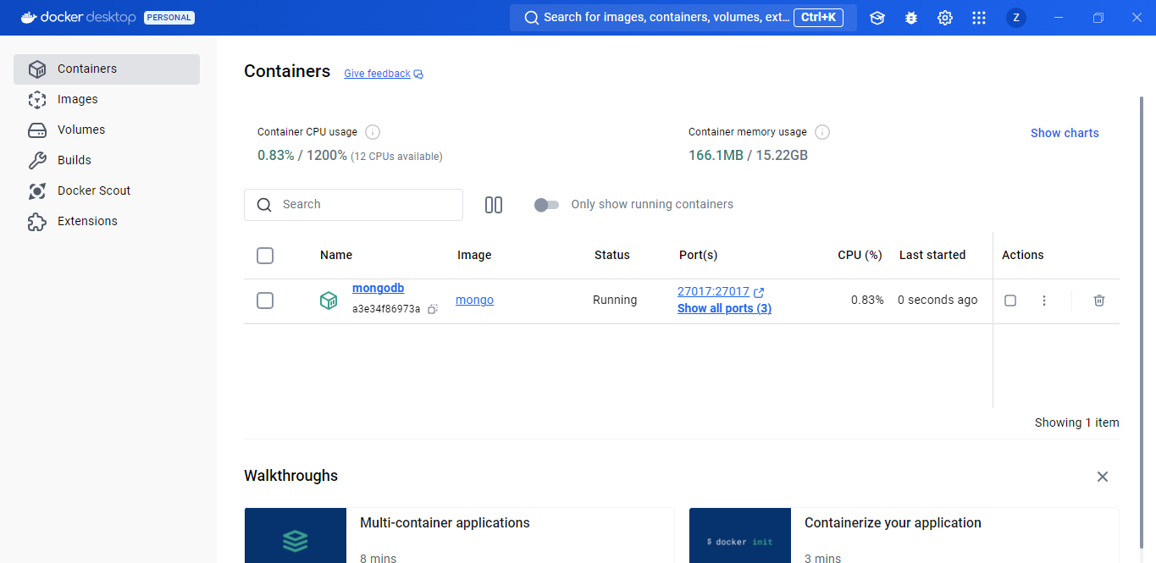

The Docker run command is functioning

